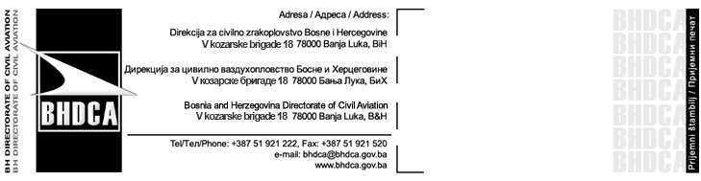
Application Form for Transport of Dangerous Goods

The form shall be submitted together with appendices* to:
Bosnia and Herzegovina Directorate for Civil Aviation
V kozarske brigade 18, 78000 Banja Luka
e-mail: flightrequest@bhdca.gov.ba
Tel: +387 51 921 222, Fax: +387 51 921 520
Only completed form with submitted documents will be processed.

Operator Data
Operator name and address
ICAO three letter code
Contact details (phone, fax, e-mail)
Aircraft Type
MTOW/Seat capacity
Aircraft Registration marks
Flight numbers
Route

Flight details
Date | Day  (1/2/3/4/5/6/7) | Flight number/s | Departure airport | ETD  (UTC) | Arrival airport | ETA  (UTC)

Dangerous goods identification
UN  number | Proper shipping name | Class or division | Packing group | Quantity | Packing instruction

Remarks

Hereby I/we do confirm, under full material and penal liability, that all details stated in this request form and in attached documents are true and fair.
Date | Name, title and signature

*Appendices:
- Shipper, Consignee,
- End User Certificate,
- UN Number(s)
- Proper Shipping name,
- Class or Division,
- Packing Group (if applicable),
- Quantity and type of packing,
- Packing Instruction according ICAO Technical Instructions,
- AOC,
- Registration,
- Airworthiness Certificate,
- Airworthiness Review Certificate,
- Insurance Certificate.

