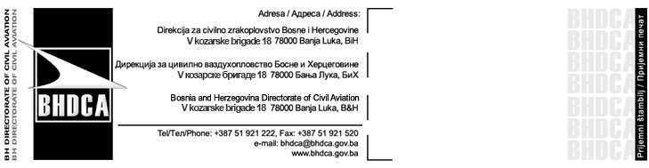
Non Schedule Service Application Form

The form shall be submitted together with appendices* to:
Bosnia and Herzegovina Directorate for Civil Aviation
V kozarske brigade 18, 78000 Banja Luka
e-mail: flightrequest@bhdca.gov.ba
Tel: +387 51 921 222, Fax: +387 51 921 520
Only completed form with submitted documents will be processed.

Operator Data
Operator name and address
ICAO three letter code
Contact details (phone, fax, e-mail)
Type of operations | Passenger | Cargo
Aircraft Type
MTOW/Seat capacity
Aircraft Registration marks
Flight numbers
Route

Category of the flight | Inclusive Tour Charter Flight | Cargo Flight
Category of the flight | Special Event Charter Flight | Other

Charterer
Name and address of the Charterer
Phone/fax, e-mail

Flight Schedule
Date | Day  (1/2/3/4/5/6/7) | Flight number/s | Departure airport | ETD  (UTC) | Arrival airport | ETA  (UTC)

Additional Information

Hereby I/we do confirm, under full material and penal liability, that all details stated in this request form and in attached documents are true and fair.
Date | Name, title and signature

*Appendices:
Charter Agreement,
Air Operator Certificate, Operation Specification (AOC)
Certificate of Registration,
Certificate of Airworthiness (CoA),
Airworthiness Review Certificate (ARC)
Noise Certificate,
Certificate of Insurance,
Aircraft Lease Agreement approved by Civil Aviation Authority (If there is any)
Security Program

